Task 3 Assignment 2

In this exercise, we use Blackbox (specification-based) design techniques to design the most important test cases to test some of the test conditions determined in task 2. Our choice of test cases is actually based on the second principle, P2: We can't test everything in the ISTQB's testing principles. The selected test cases thus constitute a subset of many available
tests, but ones with a reasonable probability of finding most of the bugs in the system. The test cases are chosen from the most important events that are possible to occur when the user interacts with the system.
Objective:
Verify that the system processes ticket buying, travel card refilling, balance inquiry, trip registration, and error conditions appropriately.

Pre-conditions:
The traveler is in front of an operational ticket machine or control module.
User interaction happens on the home screen.

Inputs:

- Select user category
- Select ticket type
- Confirmation
- Payment

Description of Use-case:
The use case illustrates user and ticket system interaction for purchasing a transport ticket. Any exceptions and exception handling are described below.

State 1 - Start window

Expected user action: Starts from the home screen and selects "buy ticket"
Expected outcome: The system shows available ticket types
Transition: To state 2

State 2 - Select ticket

Expected action: Selects the desired ticket type (Travel Card, 7-Day Ticket, 30-Day Ticket)
Expected outcome: Confirmation screen is displayed
Transition: To state 6

State 6 - Confirmation window

Expected action: User confirms or cancels
Expected outcome: If confirmed, to payment, else back to start
Transition: To state 7 or to state 1

State 7 - Payment

Expected action: Pays with payment card
Expected outcome: The payment is successful, and a ticket is printed. System goes back to (“Select Buy Tickey”)

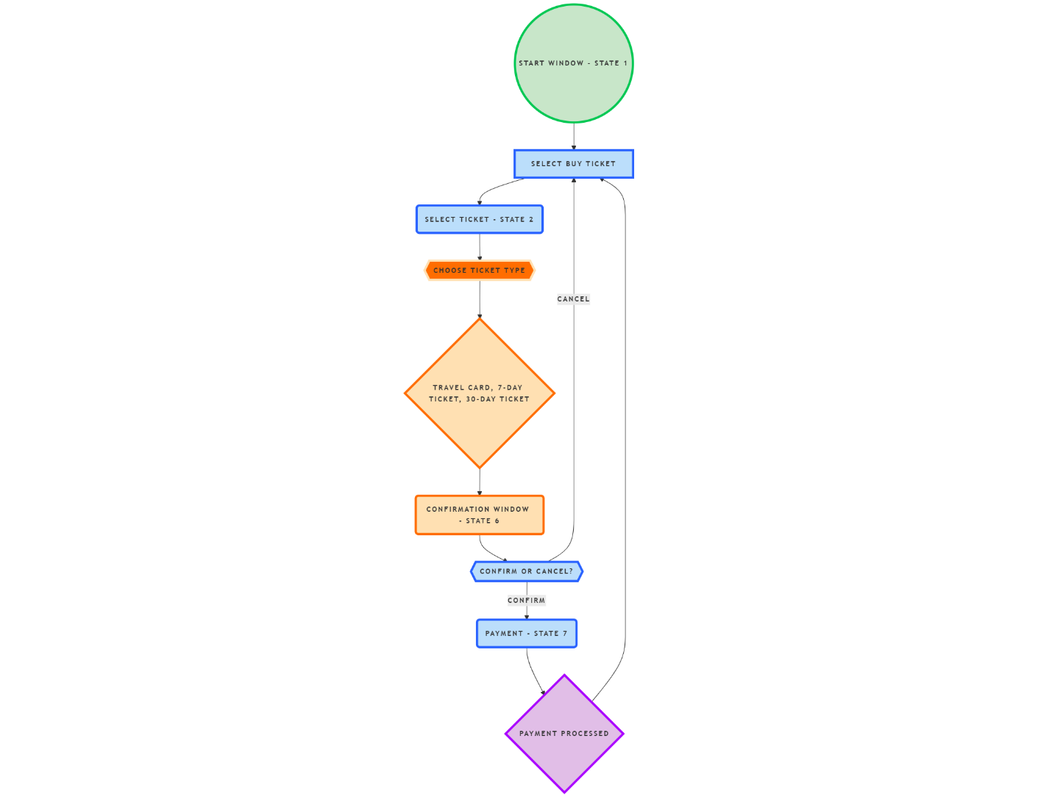
This flowchart illustrates the interactions between the different states.

Equivalent Partition
Equivalence Partitioning:
We apply equivalence partitioning to the input related to user categories eligible for discounts.

Partitions identified:

Valid partitions: Rechargeable Travel Card, 7-Day Ticket, 30-Day Ticket
Invalid partitions: Any other input (ex: blank input)

Test Cases EP:
TC-1 | Rechargeable Travel Card | Goes to deposit window | Valid
TC-2 | 7-Day Ticket | Goes to confirmation window | Valid
TC-3 | 30-Day Ticket | Goes to confirmation window | Valid
TC-4 | Invalid input (e.g., blank) | Error message and back to start | Invalid

Explanation of how EP was applied: We identified collections (partitions) of inputs that are expected to behave the same and picked one representative of each.

Coverage:
Total partitions: 4
Covered: 4
EP Coverage: 100%
All the identified equivalence partitions (EPs) were tested. The following partitions: Rechargeable Travel Card, 7-Day Ticket, 30-Day Ticket, and Invalid Input. Each has one representative test case. As all 4 partitions are covered by TC-1 to TC-4, the EP coverage achieved is 100%
Traceability:
- TC-1 → REQ-01 Requirement 1: Purchase Travel Card
- TC-EP-2 → REQ-02 Requirement 2 : Purchase 7-Day Ticket
- TC-EP-3 → REQ-03 Requirement 3: Purchase 30-Day Ticket
- TC-EP-4 → REQ-04: Input validation

Boundary Value Analysis (BVA)

BVA Usage: When money is deposited into a travel card, we apply BVA.
assumed that the minimum deposit is 1 NOK, and the maximum is 2000 NOK.

Test Cases (BVA):
Test Case | Deposit Amount | Expected Result
TC-1 | 0 NOK | Error: Below minimum
TC-2 | 1 NOK | Accept deposit
TC-3 | 1999 NOK | Accept deposit
TC-4 | 2000 NOK | Accept deposit
TC -5 | 2001 NOK | Error: Above maximum

Coverage:
Boundary values: 0, 1, 1999, 2000, 2001
BVA Coverage: 100%
All boundary values within and outside the valid range of deposit values were tested. Each boundary value was thoroughly examined to ensure the system responds appropriately to both valid and invalid inputs. Achieving full BVA coverage ensures confidence that the system effectively manages edge cases.
Traceability:
TC-1 to TC-5 → REQ 05: Recharge Travel Card

Decision table

Test case and preconditions: We apply for Decision Table Testing for ticket discounts based on traveler type and day of the week.

Decision table
Condition | Rule 1 | Rule 2 | Rule 3 | Rule 4 | Rule 5 | Rule 6
Weekday | True | False | True | False | True | False
Weekend | False | True | False | True | False | True
Adult | True | True | False | False | False | False
Child | False | False | True | True | False | False
Student | False | False | False | False | True | True
Action
Discount Applied | 0% | 30% | 0% | 100% | 0% | 50%

Coverage:
Number of rules: 6
Covered: 6
Coverage in Decision table: 100%

We tested all six decision rules, making sure each one was represented by at least one test case. This gave us full decision table coverage, ensuring that every combination of traveler type and day of the week that impacts discounts has been carefully checked and validated.
Traceability:
TC-1 to TC-6 → REQ-06: Discount Calculation Logic
(Test case 1 to case 6 covers the sixth requirement (

State Transition Testing

Goal: Verify that the system appropriately handles travel card refills, from option selection to payment.

Pre-condition: The user is at a working ticket machine, and the start window (state 1) is where the interaction begins.
Test inputs:

- Start Window
- Select Ticket/Card Window
- Read Card
- Error Message (Unknown Card)
- Deposit to Travel Card
- Confirmation Window
- Payment Window

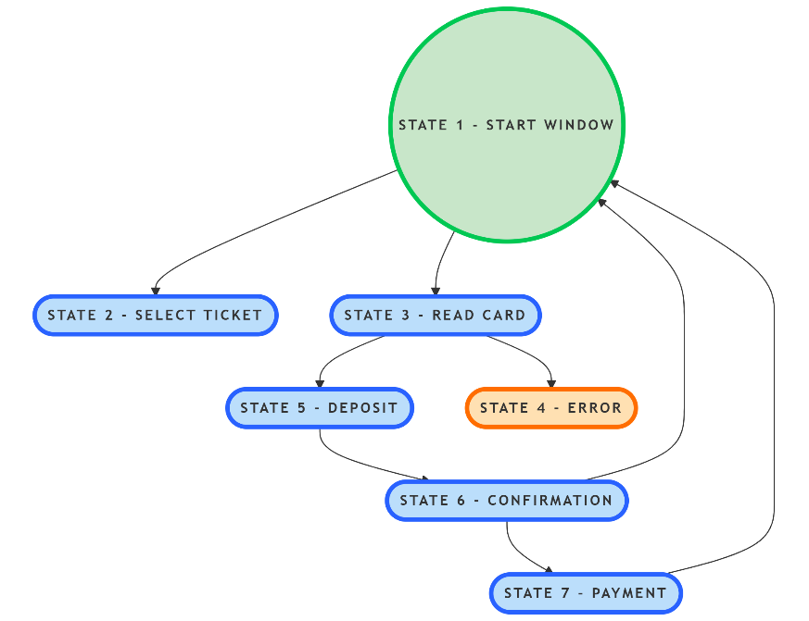
This is an illustration of the state transitions combined.

Coverage:
State coverage : 100%
Transition coverage : 100%
By achieving both 100% transition coverage and state coverage, the test ensures that the entire state machine is thoroughly examined without leaving any trace behind for testing its functional flow.

